**App Usage: General Overview**

**Navigation**

When the link to the web app is clicked, the default **Overview** page will display. The default main page displays the **Search** tab as shown below as well as an overview of two tabs on the left. This web app is divided into 2 different subsections: **Search** and **Record**. Search subsection is used for displaying the data entered for cacao shipments (boxes or lots) with a specific UID, while record subsection is used for entering data for cacao shipments (boxes or lots) with a specific UID.

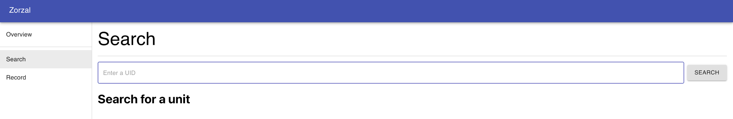

To navigate between these pages in the web app, simply click on the tabs under Overview. For example, if one clicks on the **Record** tab, the Record page will display and one can always go back to **Search** by clicking to the tab at any given point.

**RECORD: DATA ENTRY**

**Outline of Basic Tracking**

The following process flow diagram illustrates our understanding of the supply chain based on our partner calls. It is added here to better explain where along the supply chain we envision the following steps taking place. This process flow diagram represents the simplest use of our system from the start of the supply chain to the end. It is included here as a way to introduce users to the system without overloading them.

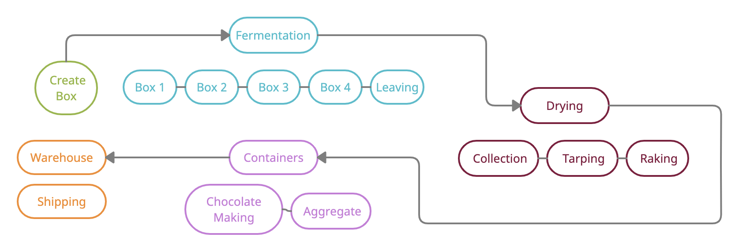

On the flow chart above, the states that are connected with each other correspond to checkpoints and

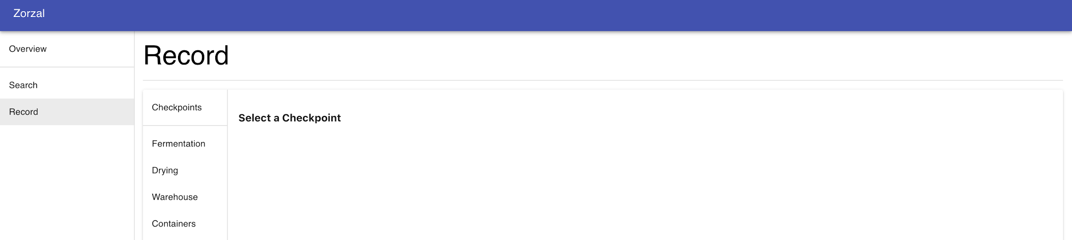

**Create Box**

1. Navigate to the Create Box by **Overview → Record → Fermentation** (**Create Box** action is the default setting of Fermentation)

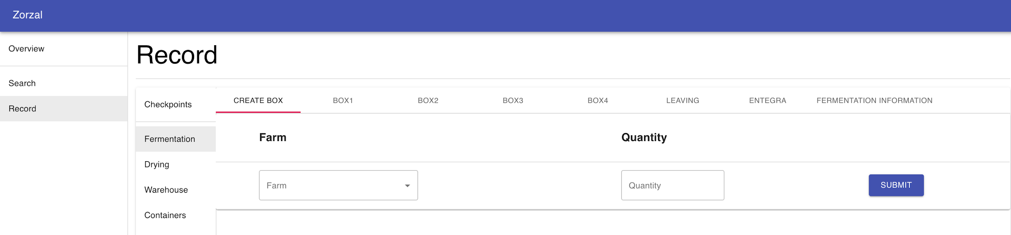

2. When a set of shipments (we call them boxes) of cacao reaches the fermentation building, enter the farm of origin by selecting the **Farm** from the drop down menu and the number of boxes to be created by entering the amount in the **Quantity**.

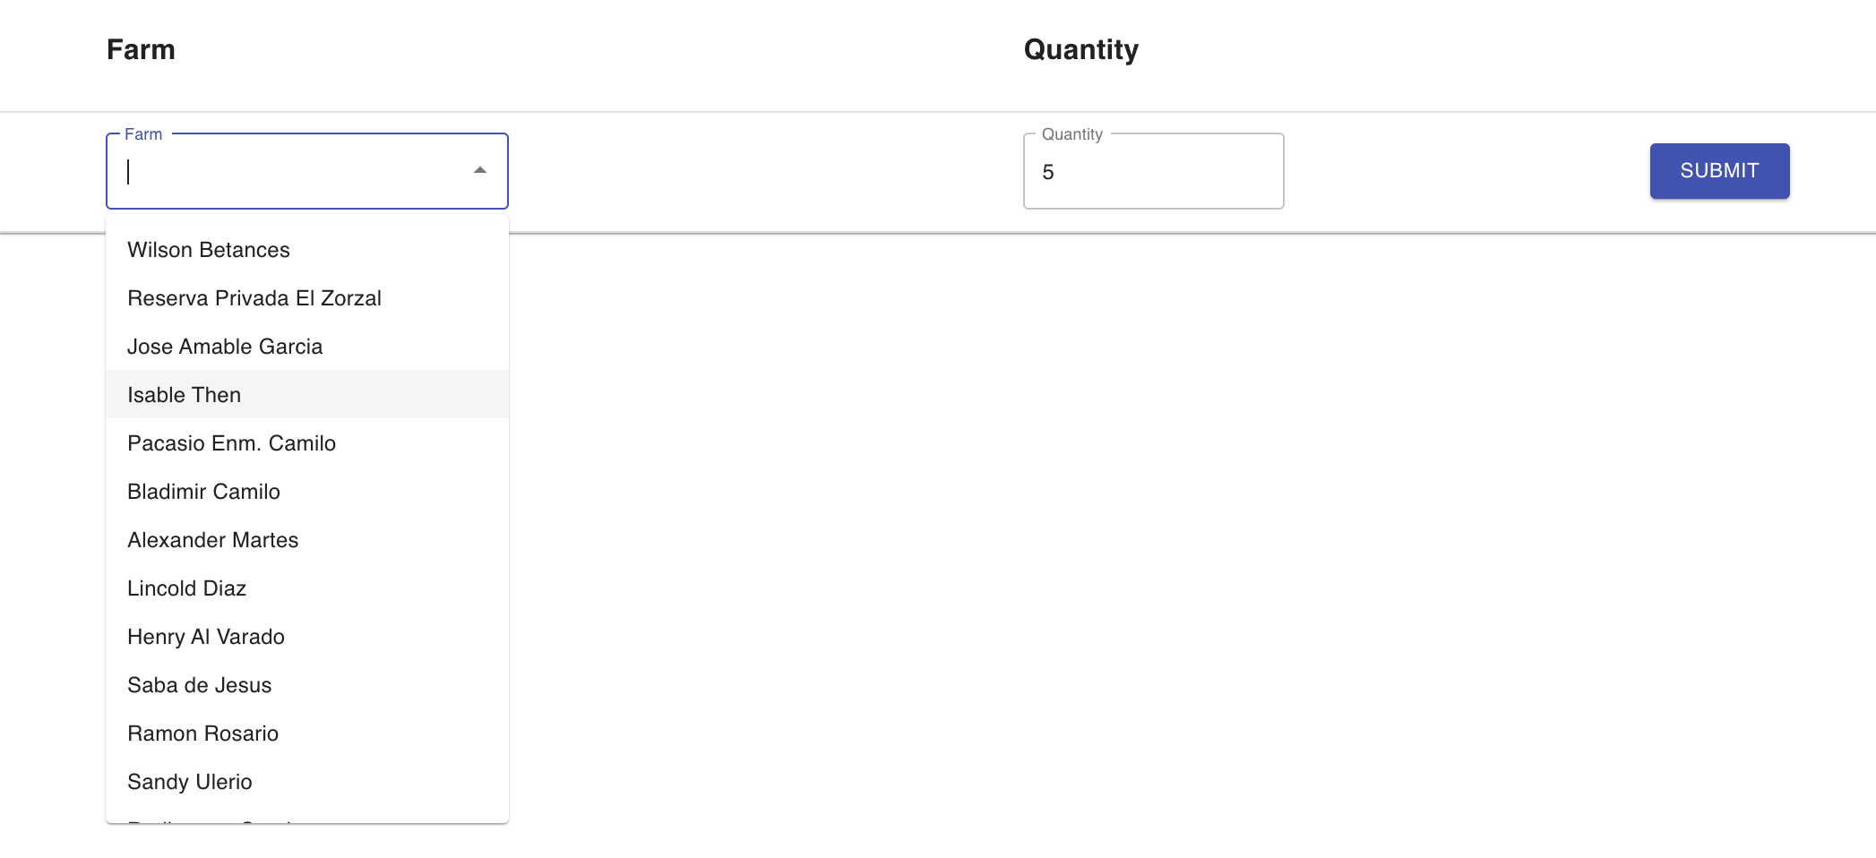

3. Upon hitting **submit**, our system then generates unique barcodes for each box

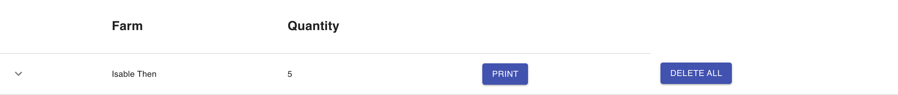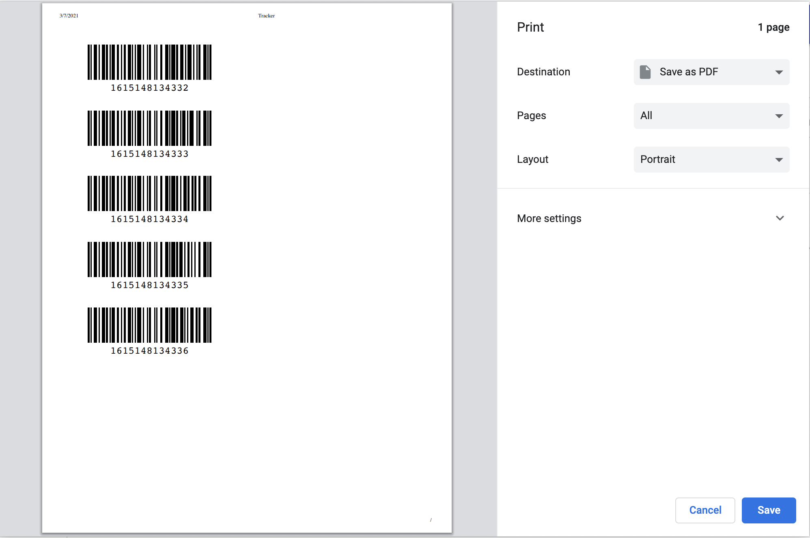

4. If you choose **Delete All**, all the data about the created boxes from this specific farm will be deleted. However, if you click to **Print**,the barcodes will be immediately rendered for printing.

\

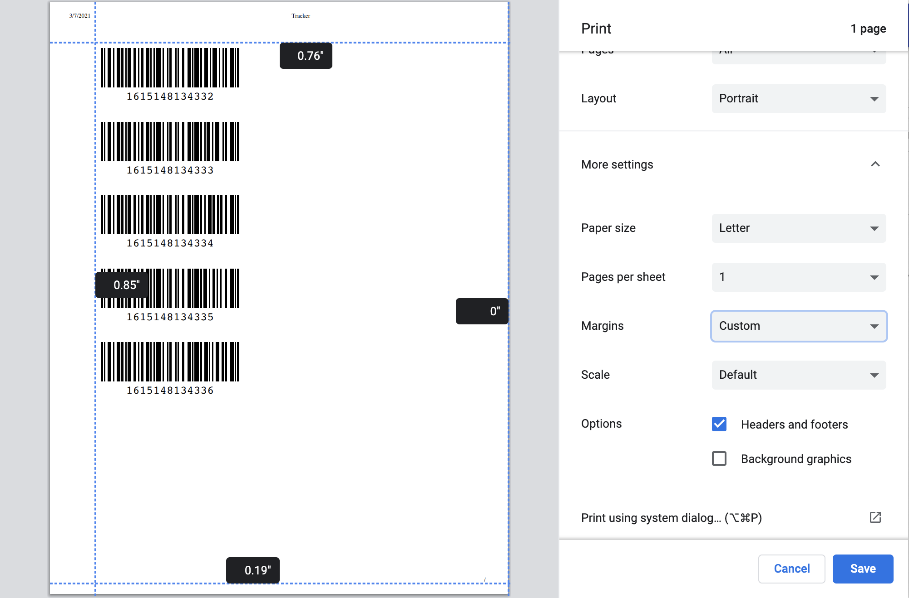

5. Before printing the barcodes, if you choose to, change the margins of the paper to locate the barcodes by navigating to

**More Options** → **Margins** → **Custom** and moving the blue dotted lines according to your preference.

6. After you are done with editing the layout, go ahead and print the unit barcodes for each box created. The UID numbers written under the barcodes for each box will be subsequently entered into the database with the associated farm of origin.

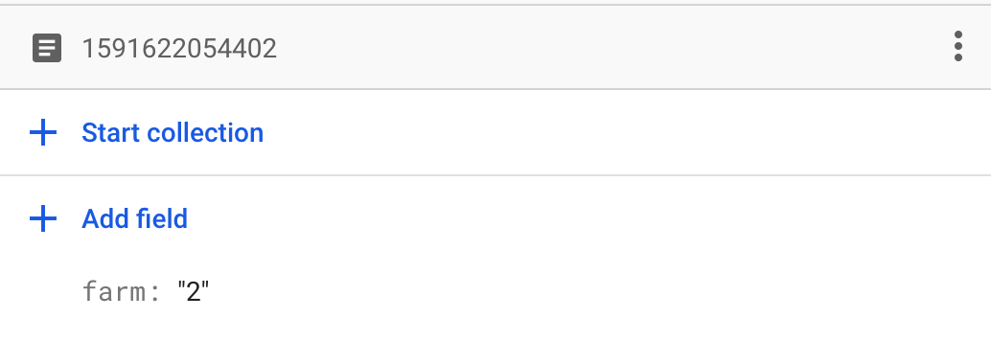

(A screenshot from the firebase database for a recently created shipment.)

7. Attach the luggage tag (barcode) that will follow the beans in this specific box throughout the supply chain. (Although the beans from a single shipment stay together in general, they do not remain in the same box throughout the supply chain. In the aggregate action that will be shown later on, multiple boxes are combined into one lot. That’s why we will use a luggage tag that moves along with the shipments as the beans move from checkpoint to checkpoint.)

**CHECKPOINTS**

**Checkpoint 1: Fermentation**

Once the box is created, it is ready to follow its path along the supply chain. The first checkpoint is **Fermentation**. Within fermentation, there are 5 different Actions that the box of beans should follow to complete this checkpoint: **Box 1, Box 2, Box 3, Box 4** and **Leaving**.

1. Navigate to **Record** → **Fermentation** → **Box 1** (Box 1 is also the default display setting for Fermentation, so you do not need to click to Box 1 specifically after selecting Fermentation)
2. Put your cursor into the Barcode box and scan the barcode of the particular box of beans that is going through the specific action you chose.

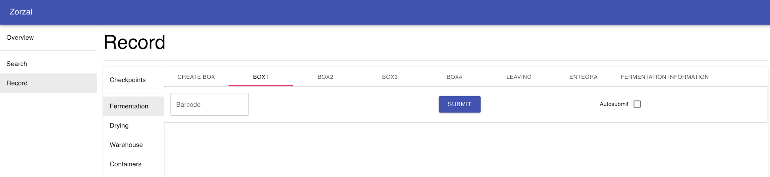

1. Click the **Submit** button. Upon submitting the timestamp for when the shipment entered the action is added to the database. This timestamp is also used as the exit time from the previous action within the checkpoint. If the **Autosubmit** box is selected within a particular Action and a barcode is scanned, this submission process happens automatically without the user needing to hit the submit button.

**NOTE:** If a user enters the barcode numbers in manually instead of scanning, the **Autosubmit** box is not recommended because once the user has typed 13 digits into the field the barcode is automatically submitted without giving the user time to confirm that the numbers typed are the correct ones.)

1. Repeat the first 3 steps for **Box 2, Box 3, Box 4** and **Leaving** by navigating to these actions in the Fermentation page.

**NOTE:** The order of actions are from left to right. However, in case, an action data is forgotten to be entered, the system does not give an error. For example, say that Box 2 action is not recorded for a particular box. Then, when the information for this box is searched, it will just not show any information about Box 2 action but still show the accurate information for every action and checkpoint remaining.

1. To record the data related to the box of beans entered in the supply chain, navigate to **Record** → **Fermentation** → **Entegra** and the form below will be displayed on the screen.
2. Put your cursor into the **Barcode** box, scan the barcode and put the related information for each box.

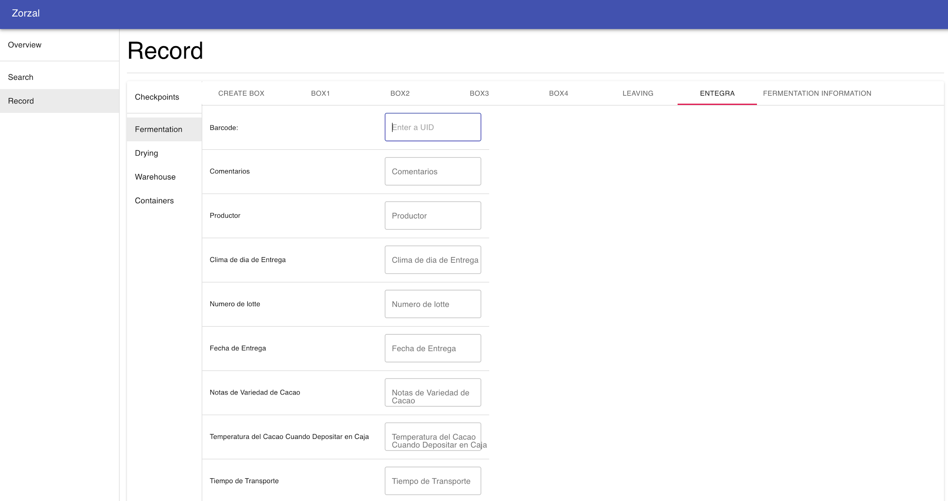

1. Once all the necessary information has been entered, click submit to record the data in the database.

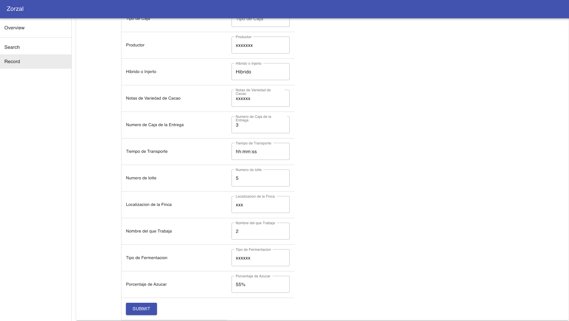

1. To record the data related to Fermentation for the box of beans entered in the supply chain, navigate to **Record** → **Fermentation** → **Fermentation Information** and the form below will be displayed on the screen.

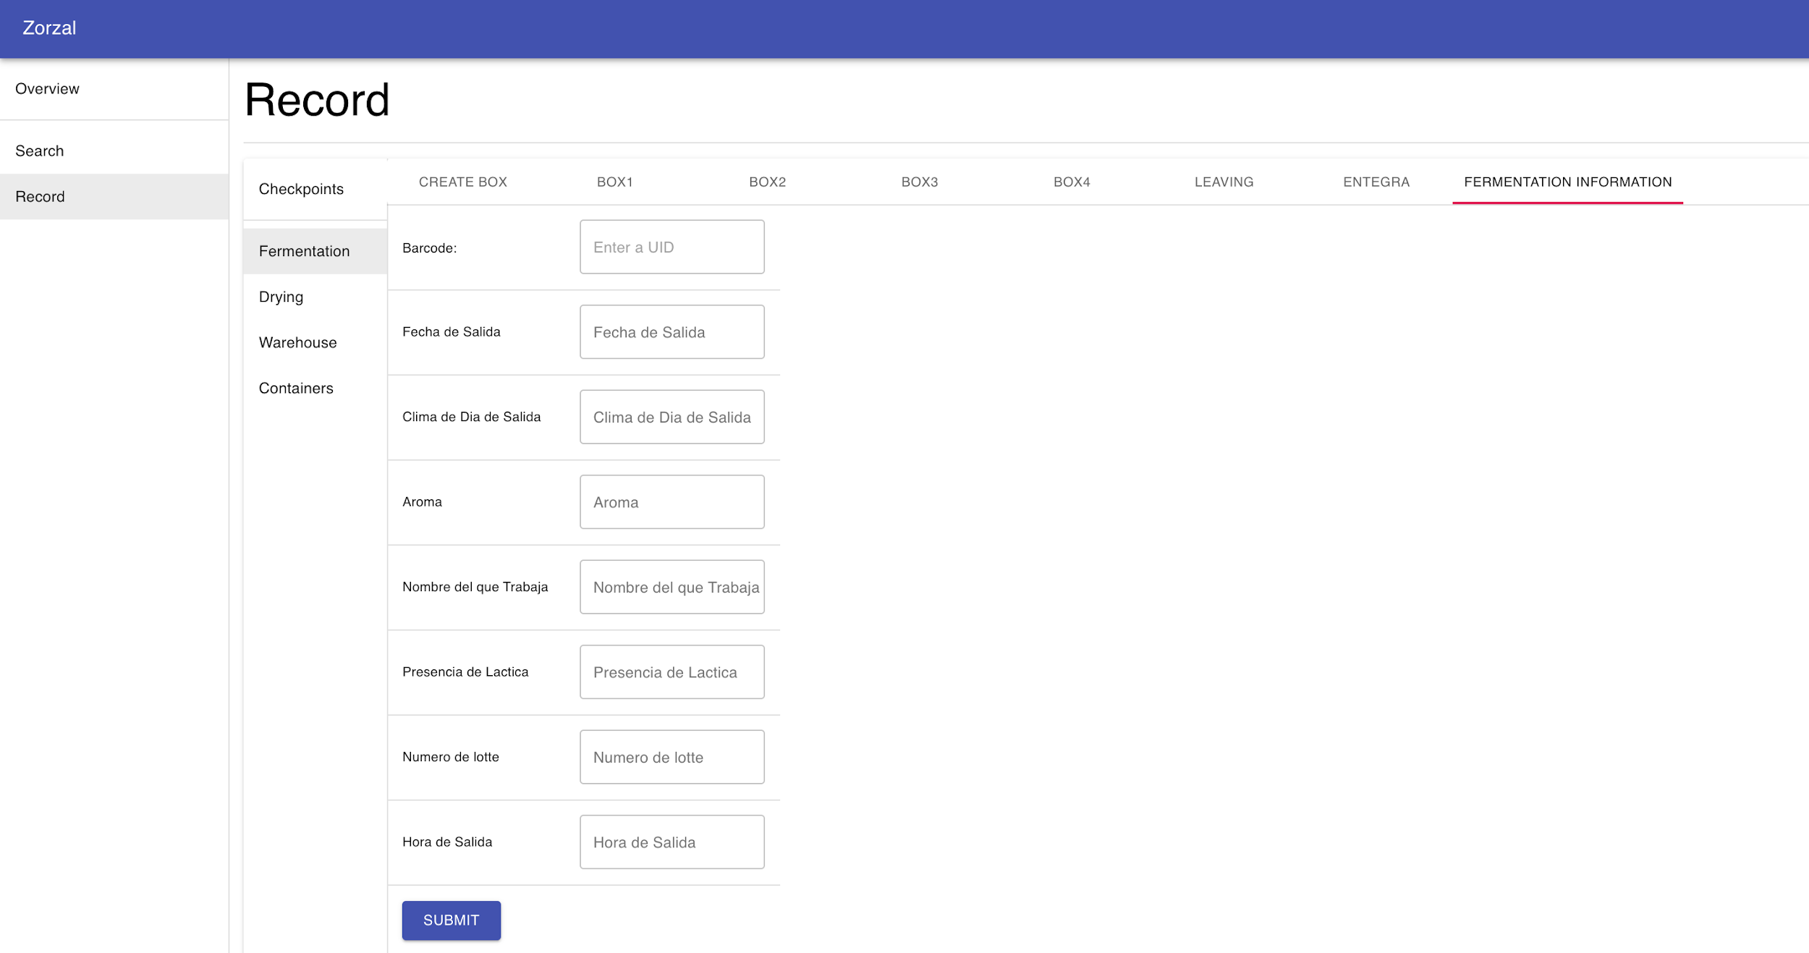

1. Repeat 6th and 7th steps for this form as well.

**NOTE:** When a specific action for a checkpoint is completed by hitting submit or through auto submission, whether the data is successfully recorded can be understood from pop-up notifications appearing on the page. For example, if Entegra or Fermentation Information is filled up correctly with right barcode UID, the following confirmation notification will occur:

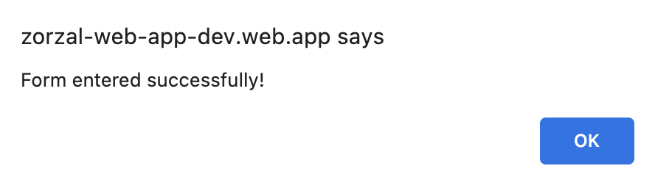

However, if the barcode UID is not valid or any other error occurred in the process, an error message will occur:



Likewise, a confirmation notification or error message will appear for every single action. For example, while creating a box, if a farm is not selected, the following error message will appear:

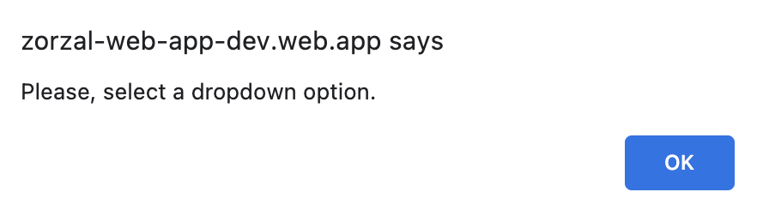

In either case, click **OK** and repeat or proceed to the next action depending on the notification message.

**Checkpoint 2: Drying**

After **Fermentation**, the next checkpoint is Drying which has 3 different Actions that the box of beans should follow to complete this checkpoint: **Raking, Tarping** and **Collection** followed by a form to enter the information regarding a Drying for specific box: **Drying Information.**

You can navigate to each Action through **Record → Drying → (Raking, Tarping** or **Collection).** 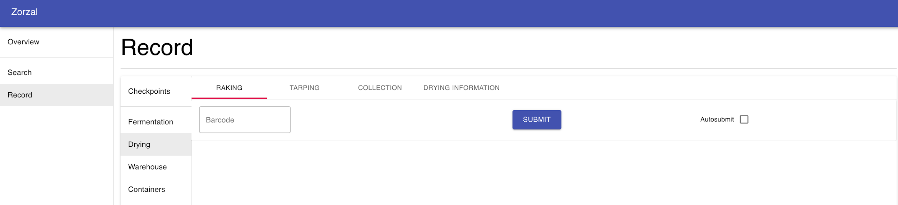

You can navigate to the form through **Record → Drying → Drying Information.**

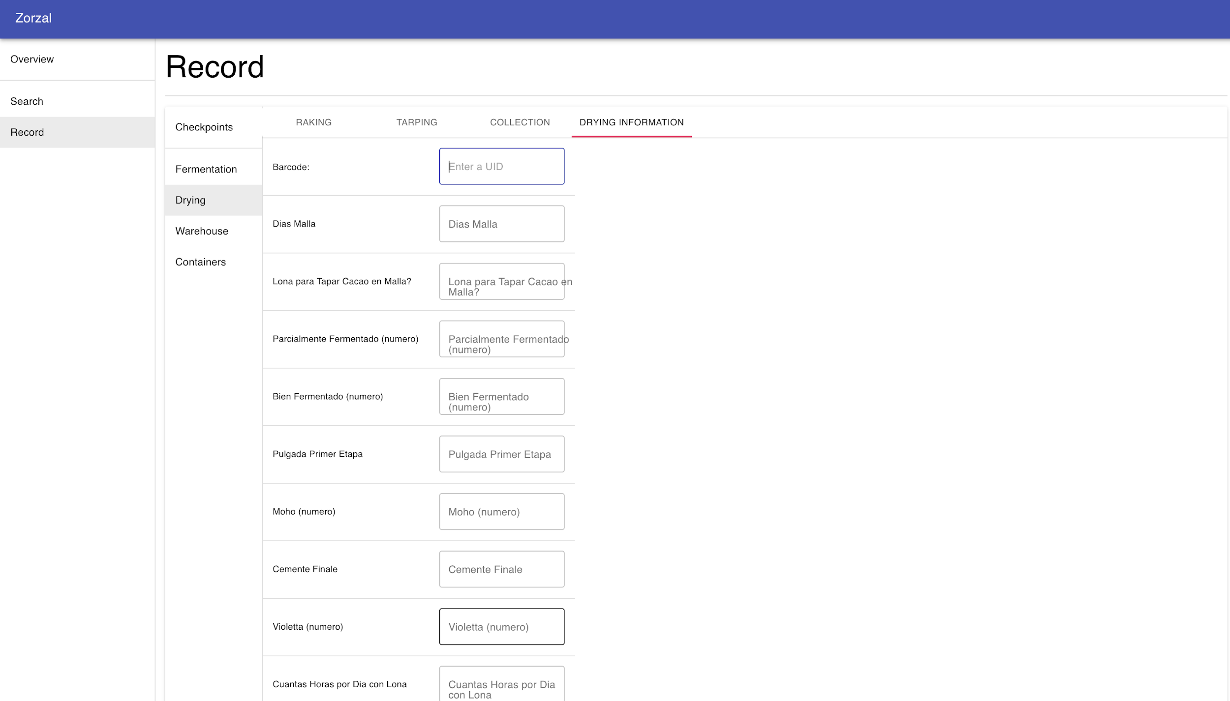

* The data for actions and forms of the Drying Checkpoint are entered in the exact way the data is entered for actions and forms of the Fermentation.

**Checkpoint 3: Warehouse**

**Record → Warehouse → Aggregate**

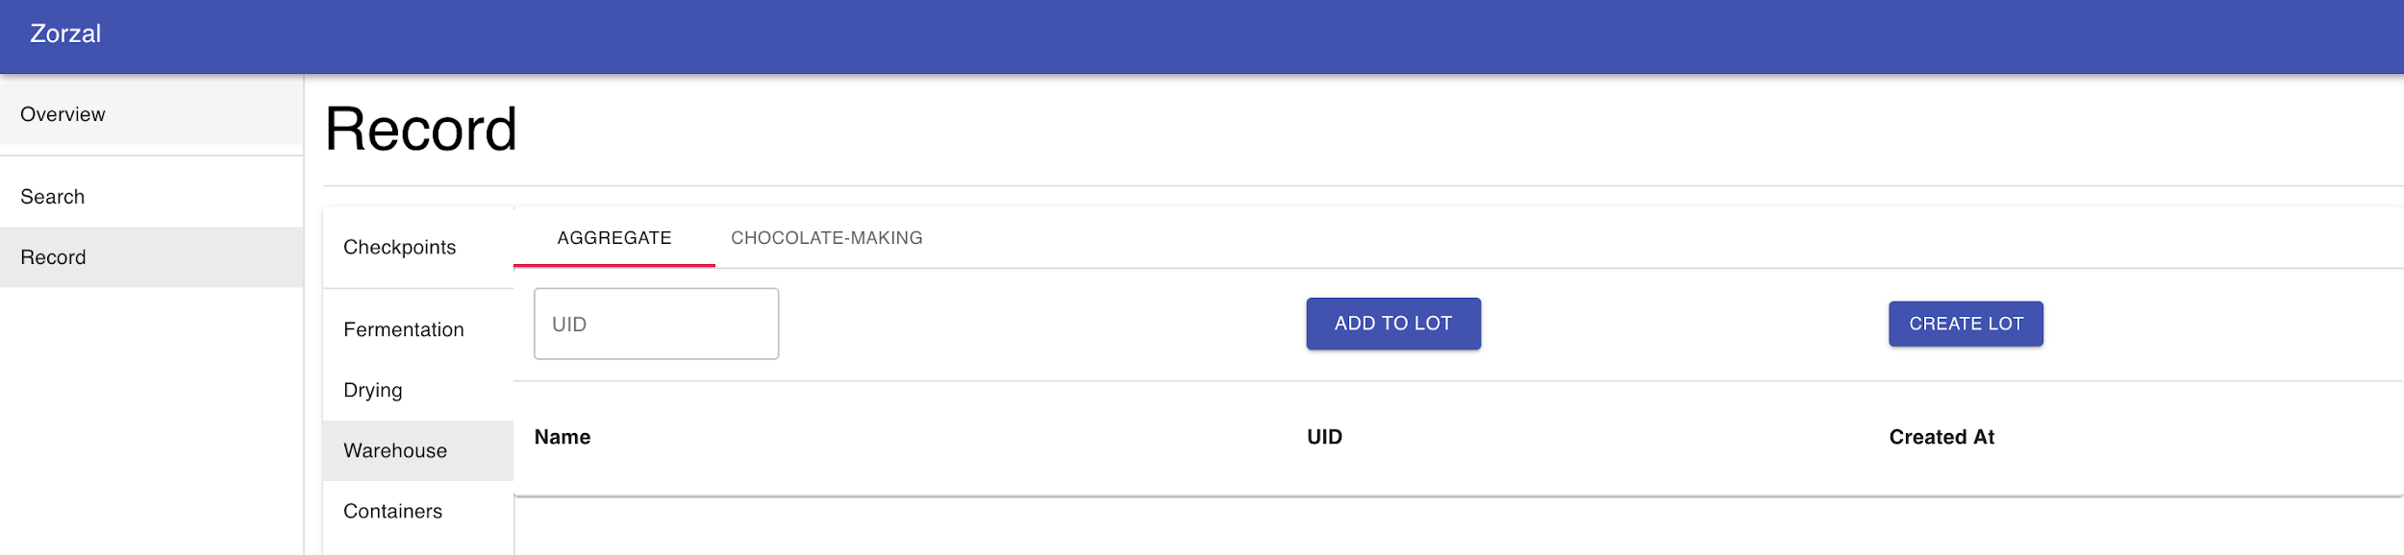

**Record → Warehouse → Chocolate-Making**

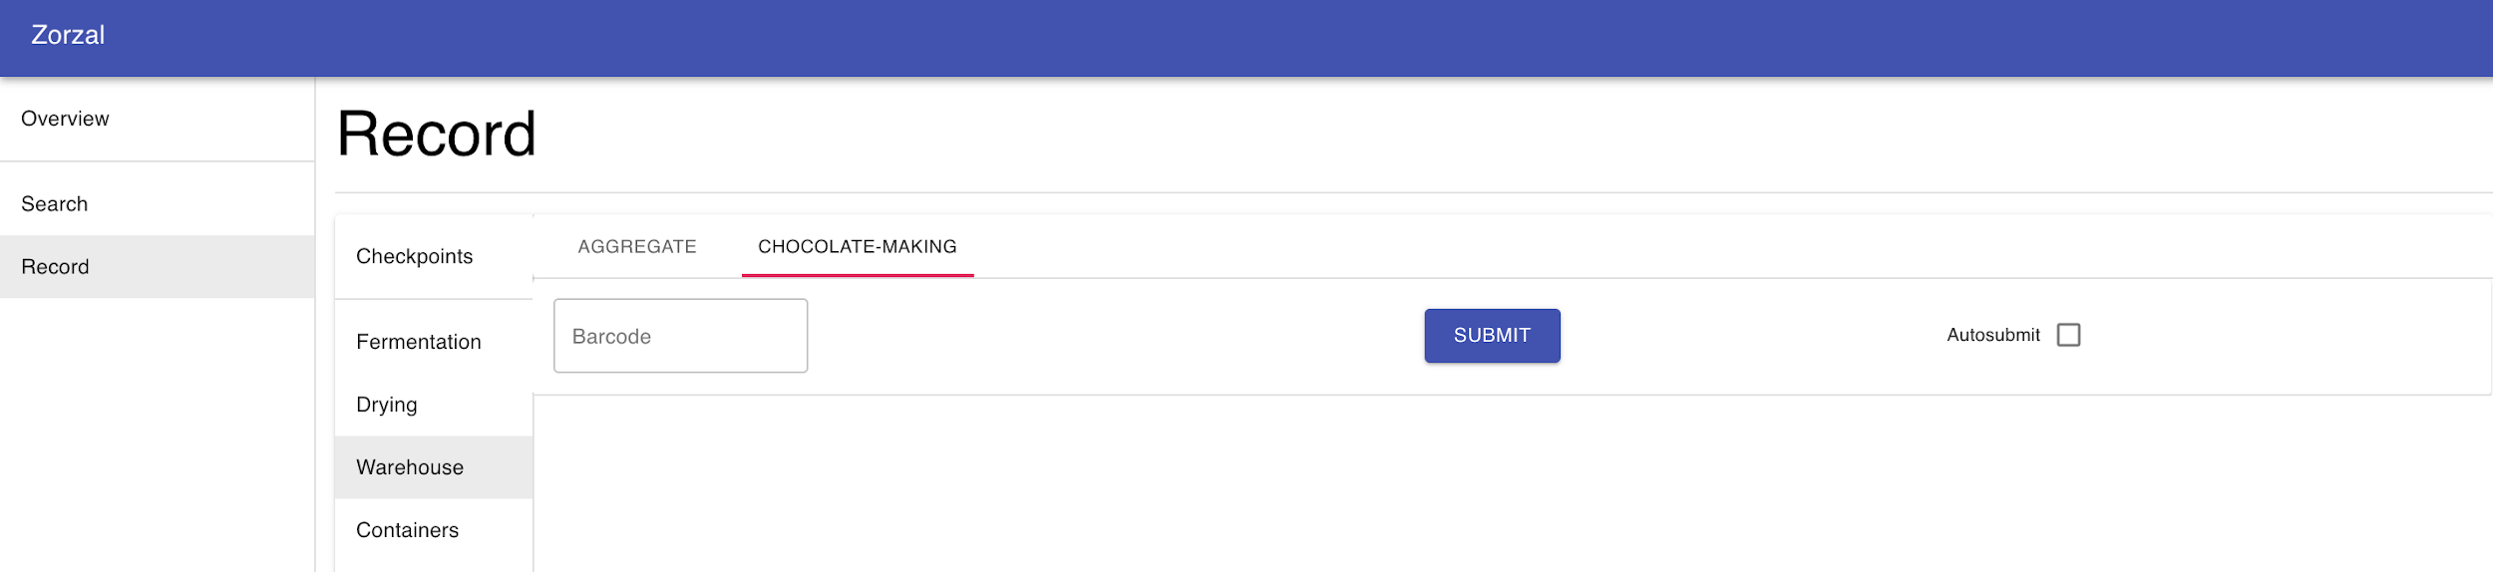

**Checkpoint 4: Containers**

**Record → Containers → Shipping**

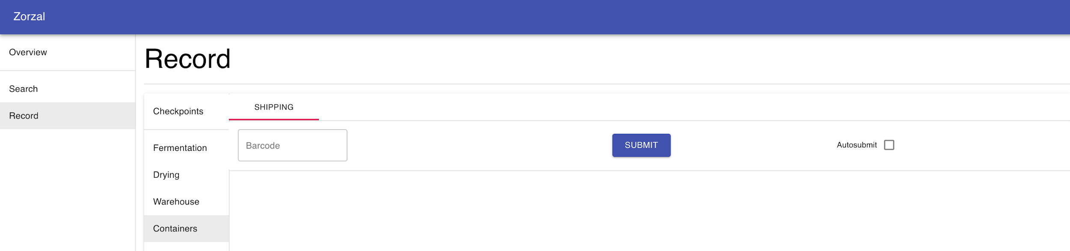

**SEARCH: DATA DISPLAY**

If a worker or a quality control manager would like to look up more precise data for an unit, which can be a single **box** of beans or a **lot** containing multiple boxes of beans, they follow the instructions below:

1. Navigate to **Search** by clicking to Search on the left side of the web application

**NOTE:** Data about a particular box or a lot could be searched anytime after it is created in the **Create Box** Action (under **Overview → Record → Fermentation**) for information related to a box and after **Create Lot** Action (at **Record → Warehouse → Aggregate**) for information related to a lot.

1. Put your cursor on the Search box Scan the UID of the lot or box to look up and click **Search**. The information for the specific unit will then be displayed to the screen. In the case below, the unit whose information is displayed is a **box**:

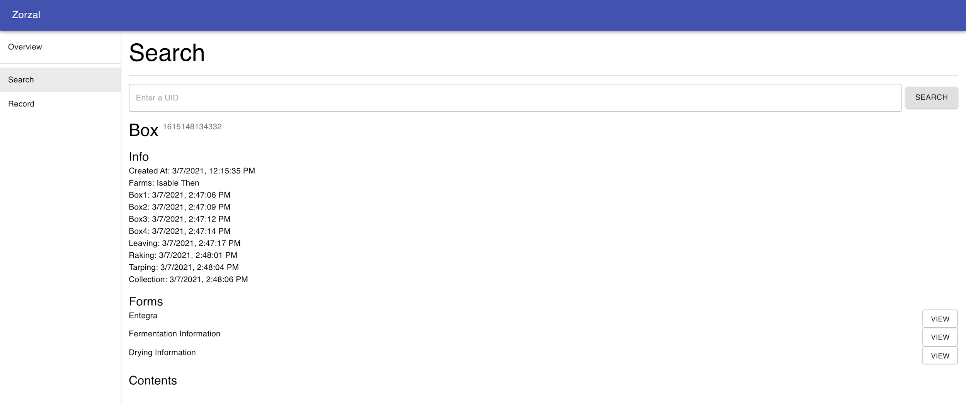

The preliminary information about the unit is going to be the date and the time it entered specific actions in different Checkpoints along the supply chain process.

1. To look up for more information from the forms click the **View**  for each form. In the case below, the form whose information is displayed is **Entegra**, which is a form under the Fermentation Checkpoint:

